**MODELRESUME**

MANIGAYATHRI.

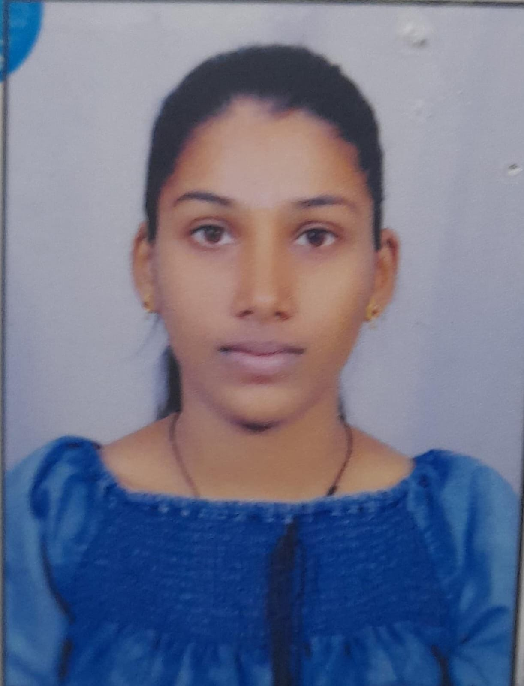

# NAME

# PITTALA MANIGAYATHRI

**Phone:** 8919273595

**E-mail:** [gayathripittala2003@gmail.com](mailto:gayathripittala2003@gmail.com)

# CAREEROBJECTIVE

To obtain a challenging position as a Software Engineering leading multi-national organization where I can use my qualifications and skills to prove my abilities.

# EDUCATIONALQUALIFICATIONS

|  |  |  |  |  |  |  |
| --- | --- | --- | --- | --- | --- | --- |
| **S.**  **No.** | **Examination Passed** | **Name**  **Of Institute/ University** | **Discipline/ Subject** | **Month & Year of Passing** | **Percen- tage of Marks** | **Division** |
| 1. | B.Tech | ACE Engineering College, Hyderabad | Computer Science& Engineering. | April 2025 | 80 | First |
| 2. | Intermediate | Board of Inter Education, T.S., Warangal. | Maths, Physics, Chemistry. | March 2021 | 81 | First |
| 3. | S.S.C | Board of Secondary Education, T.S., Yadadribhongir. | Maths, Science, SocialStudies | March 2019 | 97 | Distn. |

**TECHNICALPROFILE**

1. Operating Systems : MS-DOS, Windows2000&XP.
2. Languages : C, Java, Python

# ACHIEVEMENTS

* + - Qualified on MERIT in NATIONAL APTITUDE TEST.
    - Won Prizes in Essay Writing and Elocution, Sports & Games.

# STRENGTHS

* + - Positive Attitude
    - Determination
    - Team Management
    - Patience

# WEAKNESSES

* + - Have a difficulty in saying NO
    - Being particular about perfection

# HOBBIES

* + - Reading Books
    - Listening to Music
    - Travelling

# PERSONALPROFILE

Date of Birth : 29th September 2003 Languages known : English, Telugu, Hindi. Father's Name : P. Uppalaiah

Mother’s Name : P. Aruna

Address : 1-274, Aler Yadadri Bhongir Telangana-508101

# DECLARATION:

Here by acknowledged that the information furnished above is true to my knowledge.

Place: Hyderabad **Signature**

Date: 13/02/2024

* * *